Front End Engineering-II

Project Report

Semester-IV (Batch-2022)

Title of the project :-

**Yoga Class Website**



**Supervised By:**

Raveesh Samkaria

**Submitted By:**

Tanisha

Roll Number: -2210990892

Group - 13

## Department of Computer Science and Engineering Chitkara University Institute of Engineering & Technology,

**Chitkara University, Punjab**

FEE-II, 22CS0014

1

# Abstract

In recent years, the popularity of yoga has surged globally, prompting the need for accessible, user-friendly digital platforms to facilitate yoga practice and community engagement. This abstract outlines the development and features of a modern yoga website built using React, a robust JavaScript library known for its efficiency and flexibility in creating interactive user interfaces.

The primary objective of the website is to provide a comprehensive online resource for yoga practitioners of all levels. It aims to offer instructional videos, live class schedules, community forums, and personalized user experiences.

The yoga website built using React offers a rich, engaging platform that caters to the diverse needs of yoga practitioners. By leveraging modern web technologies, the site not only enhances user experience but also provides scalable and maintainable solutions for content management and community interaction. This project underscores the potential of React in developing high-performance, user-centric web applications.

This abstract serves as a foundational overview for developers, stakeholders, and users interested in the technical and functional aspects of the yoga website.

FEE-II, 22CS0014

2

# Table of Contents

|  |  |  |
| --- | --- | --- |
| **Sr.no** | **Section** | **Page No.** |
| **1** | **Introduction** | 4 |
| **2** | **Problem Statement** | 5 |
| **3** | **Technical Details** | 6 |
| **5** | **File Structure** | 7 |
| **6** | **Result** | 8-22 |
| **7** | **References** | 23 |
|  |  |  |

FEE-II, 22CS0014

3

# Introduction

The primary purpose of the yoga website is to provide a centralized hub for yoga enthusiasts of all levels—beginners, intermediate practitioners, and advanced yogis. Our vision is to create a vibrant online community where users can access high-quality instructional content, participate in live classes, engage with fellow practitioners, and track their personal progress. The website aims to bridge the gap between traditional in-person yoga sessions and the convenience of digital accessibility, ensuring that everyone can benefit from yoga regardless of their location or schedule.

React was chosen as the cornerstone of this project due to its numerous advantages in developing modern web applications:

**1.Component-Based Architecture:** React’s modular approach allows for the creation of reusable components, enhancing development efficiency and consistency across the site.

**2.Virtual DOM:** This feature improves performance by minimizing direct interactions with the actual DOM, resulting in faster updates and rendering.

**3.Flexibility and Scalability:** React’s ecosystem supports a wide range of tools and libraries, making it easy to integrate additional functionalities as the website grows.

**4.Strong Community and Support:** React boasts a large, active community, providing extensive resources, tutorials, and third-party libraries to aid development.

This yoga website represents a significant step forward in the fusion of technology and wellness. By leveraging React’s capabilities, we aim to provide a platform that is not only functional and efficient but also enriching and inspiring for its users. Whether you are a seasoned yogi or just beginning your journey, our website offers the tools and community support to help you thrive in your practice.

FEE-II, 22CS0014

4

# Problem Statement

# In today's fast-paced world, finding the time and resources to engage in regular yoga practice can be challenging. Traditional yoga studios and classes often present barriers such as fixed schedules, geographic limitations, and high costs, which can deter individuals from maintaining a consistent yoga routine. Additionally, the COVID-19 pandemic has highlighted the need for accessible, at-home fitness solutions, further emphasizing the necessity for a robust online platform that caters to the diverse needs of yoga practitioners.

Despite the proliferation of online yoga content, many existing platforms lack the comprehensive features and user-centric design required to fully support users in their yoga journeys. These shortcomings include:

**Limited Accessibility and Flexibility:** Many online yoga resources are not optimized for all device types, leading to poor user experiences on mobile devices and tablets. Fixed class times and a lack of on-demand content further limit accessibility.

**Fragmented User Experience:**

Users often need to navigate multiple websites or apps to access different types of content, such as instructional videos, live classes, and community forums. This fragmentation can be frustrating and time-consuming.

**Lack of Personalization:**

Existing platforms frequently fail to offer personalized content recommendations, progress tracking, and tailored practice plans, which are essential for maintaining user engagement and motivation.

**Inadequate Community Engagement:**

The absence of social features and community-building tools can leave users feeling isolated in their practice, depriving them of the support and encouragement that come from a connected yoga community.

**Performance Issues:**

Slow loading times, buffering videos, and inefficient navigation can detract from the overall user experience, discouraging consistent use of the platform.

FEE-II, 22CS0014

5

# Technical Details

**Frontend:**

* **React:** A JavaScript library for building user interfaces. React's component-based architecture allows for the creation of reusable UI components.
* **Redux:** State management library to manage the global state of the application efficiently.
* **React Router:** Library for dynamic routing to enable seamless navigation within the application.
* **Material-UI:** React component library for implementing Google's Material Design, ensuring a cohesive and visually appealing UI.

**Backend:**

* **Node.js:** JavaScript runtime for building scalable server-side applications.
* **Express.js:** Web application framework for Node.js to handle HTTP requests and implement RESTful APIs.
* **MongoDB:** NoSQL database for flexible and scalable data storage.
* **Mongoose:** Object Data Modeling (ODM) library for MongoDB and Node.js, providing a schema-based solution to model application data.

**Authentication:**

* **OAuth 2.0:** Protocol for secure authorization, enabling social logins (Google, Facebook).
* **JWT (JSON Web Tokens):** Standard for securely transmitting information between parties as a JSON object.

**Deployment and Hosting:**

* **AWS (Amazon Web Services):** Cloud platform for hosting the backend and database services.
* **Netlify/Vercel:** Frontend deployment platforms optimized for React applications.
* **GitHub Actions:** Continuous Integration/Continuous Deployment (CI/CD) pipelines for automated testing and deployment.

FEE-II, 22CS0014

6

# File Structure: -

**1. public/**

* Contains static assets such as HTML template, images, and favicon.

**2.src/**

* The main source directory for the React application.

**3. assets/**

* Stores images, fonts, and other static assets.

**4. components/**

* Contains reusable UI components, each in its own folder with associated CSS and subcomponents.

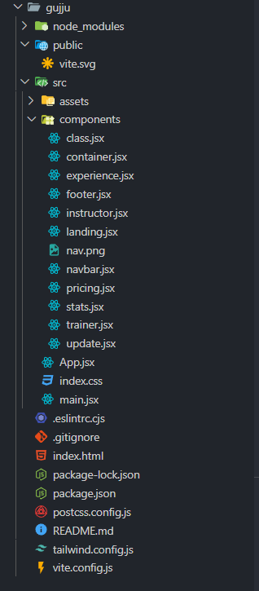

FEE-II, 22CS0014

7

**Result:**

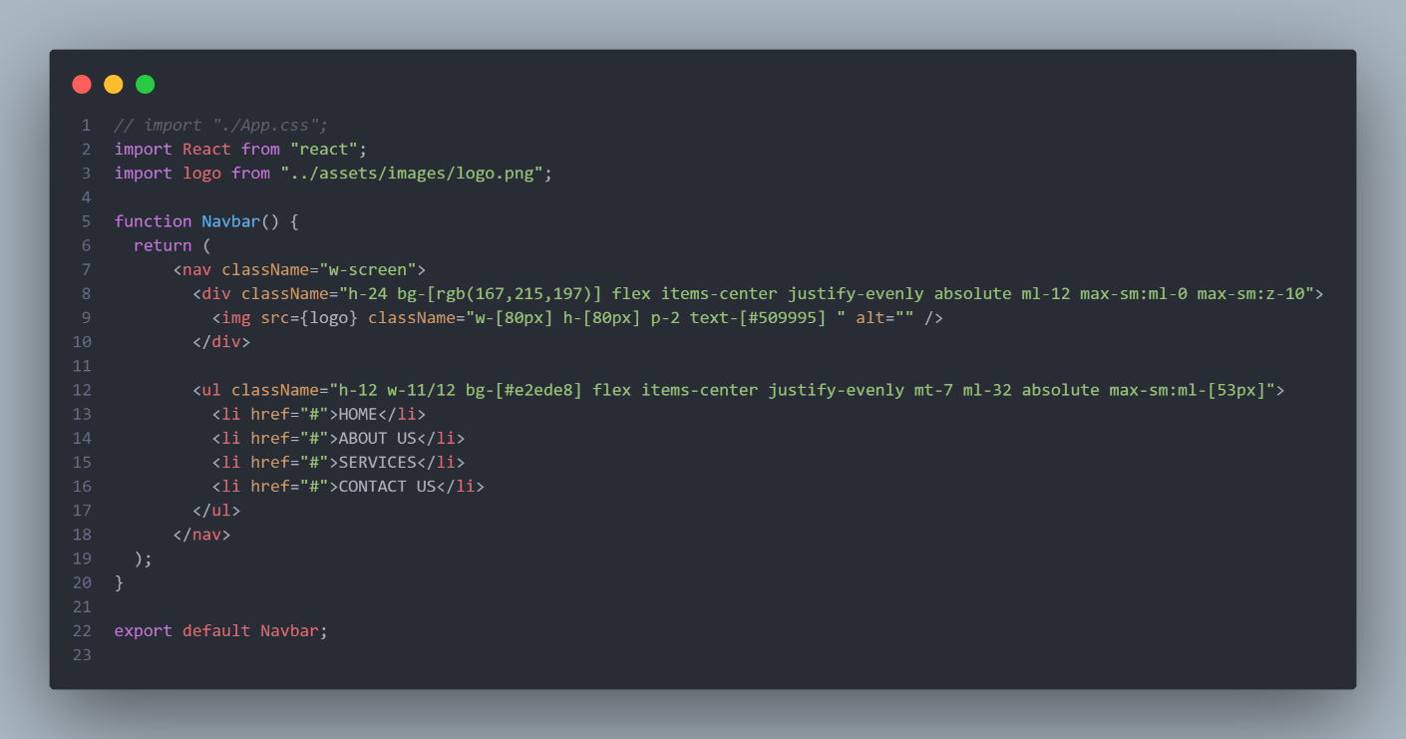

**Navbar.jsx**

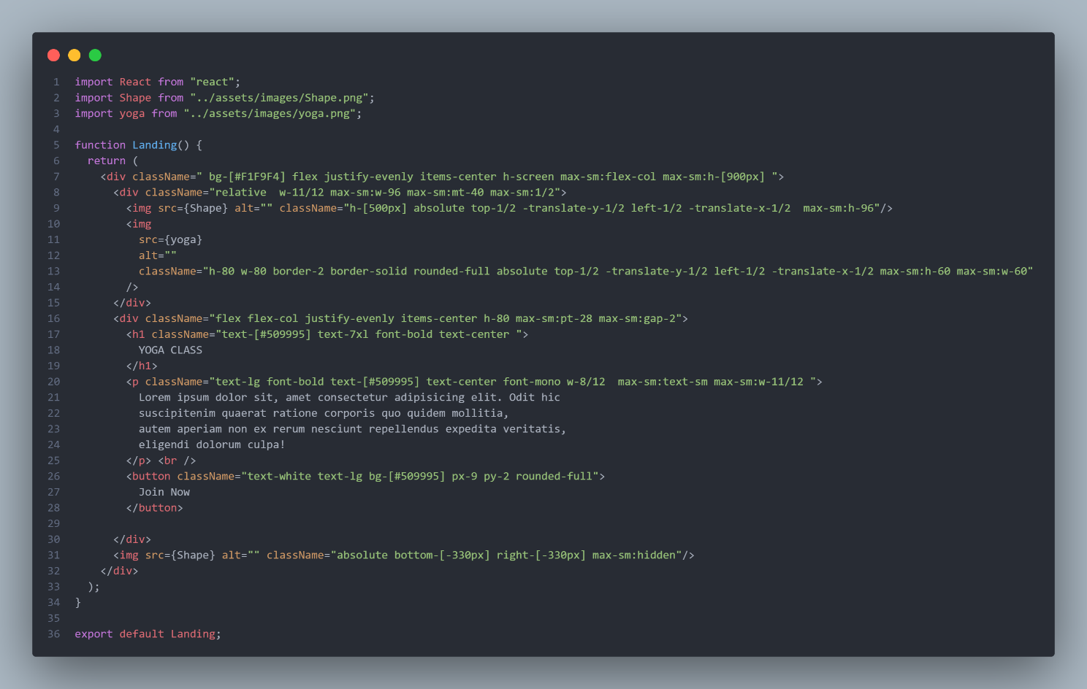

**Landing.jsx**

FEE-II,22CS0014

8

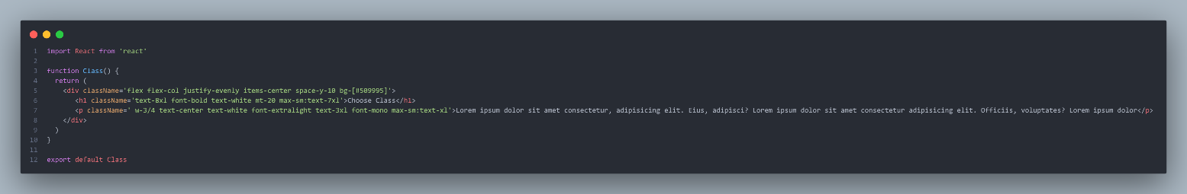

**Class.jsx**

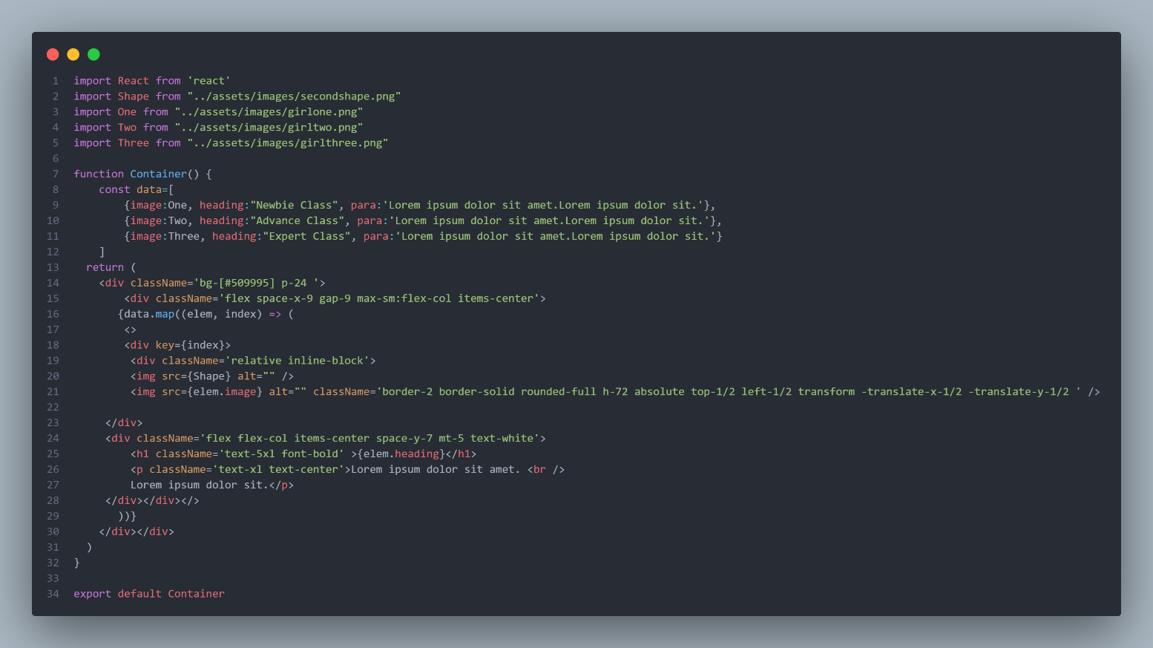

**Container.jsx**

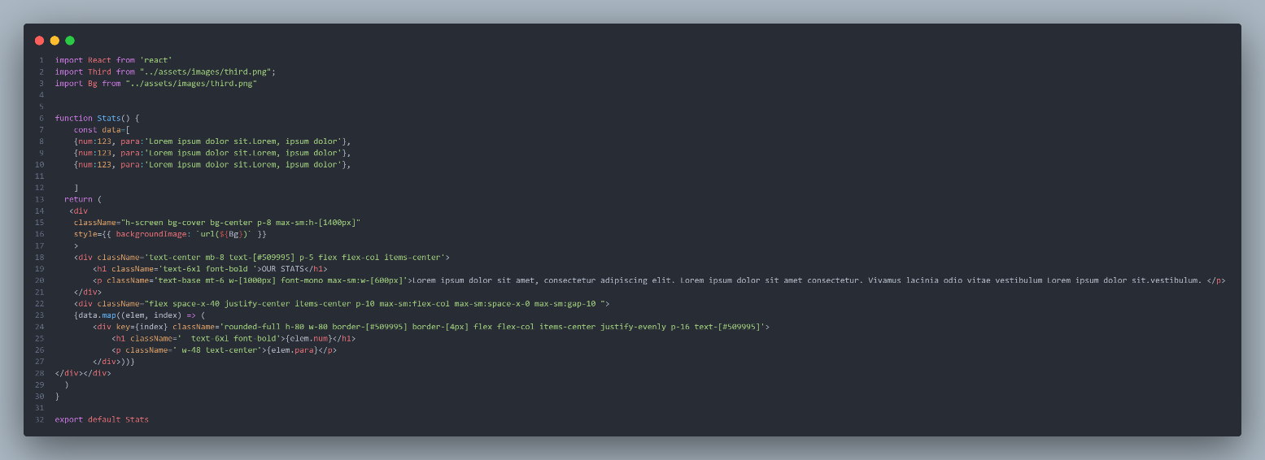

**Stats.jsx**

FEE-II, 22CS0014

9

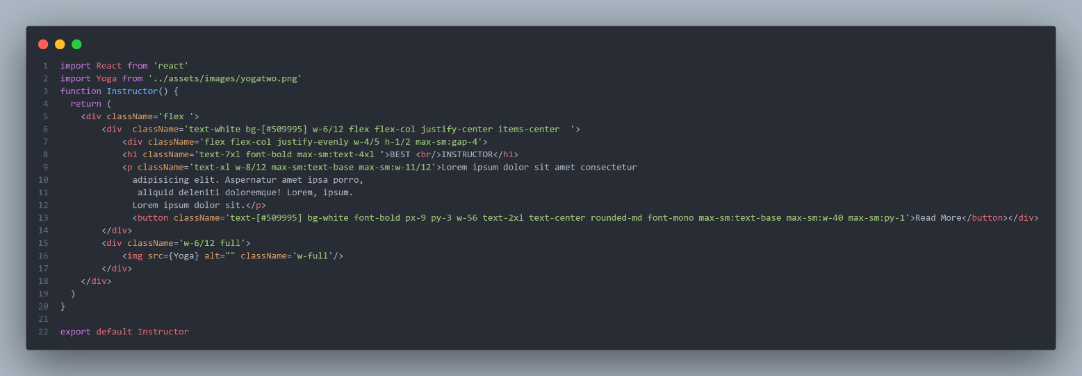

**Instructor.jsx**

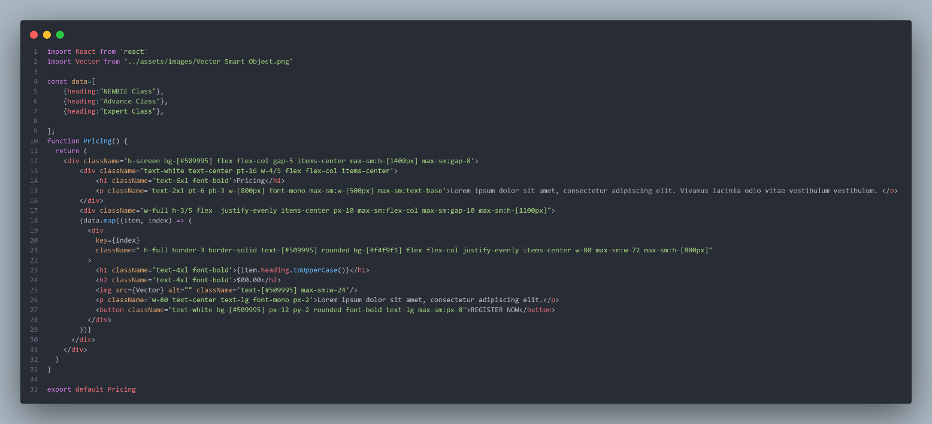

**Pricing.jsx**

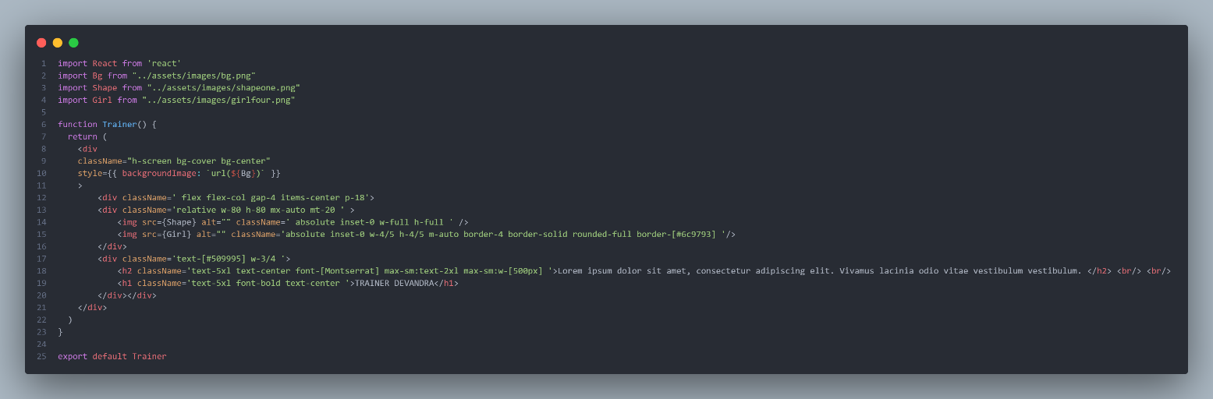

**Trainer.jsx**

FEE-II,22CS0014

10

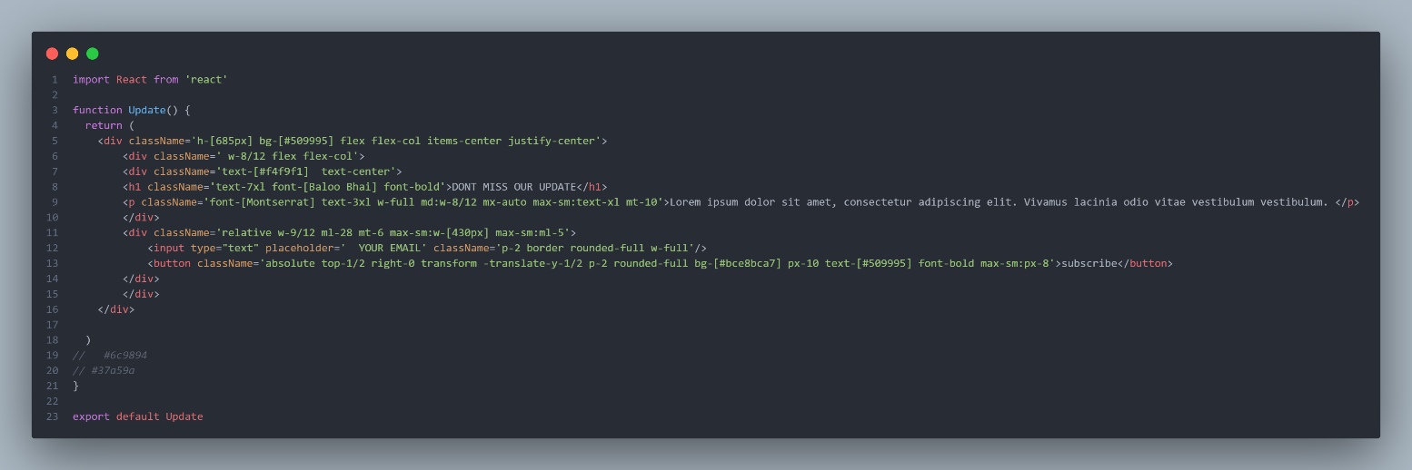

**Update.jsx**

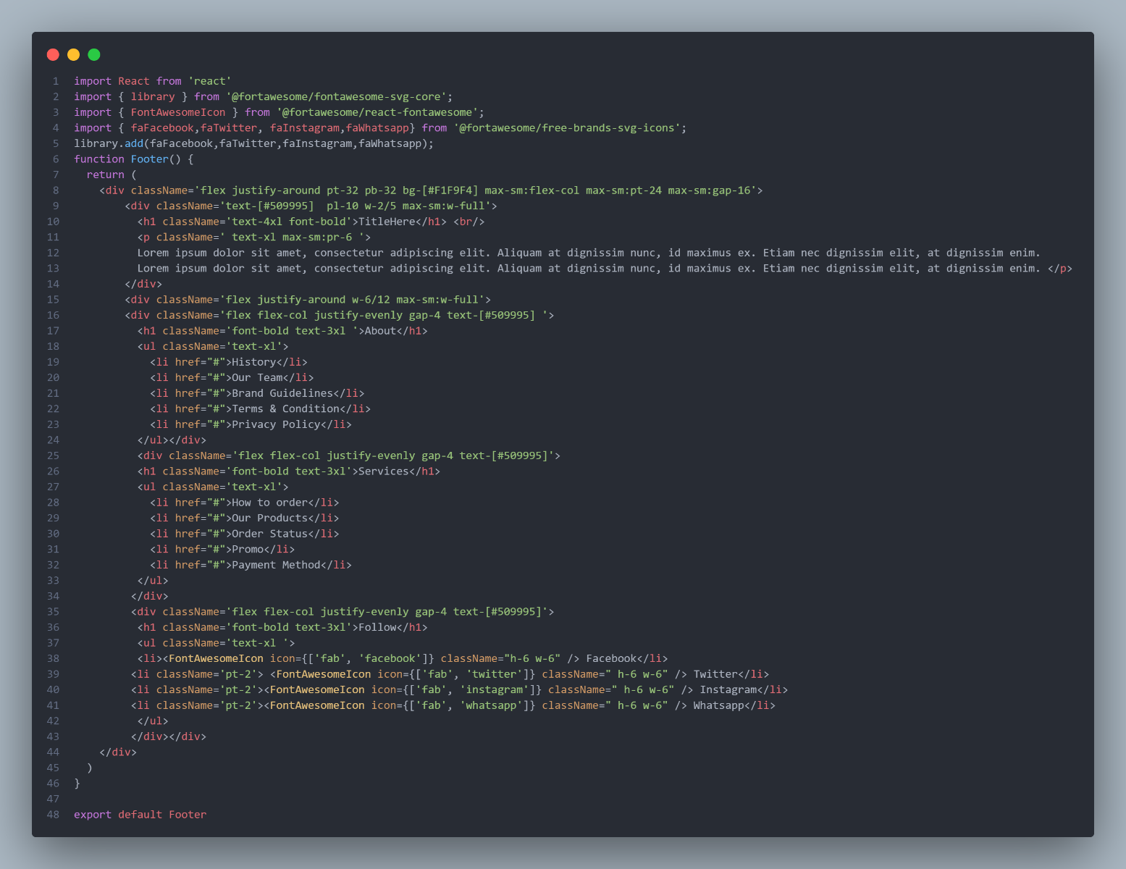

**Footer.jsx**

FEE-II,22CS0014

11

**Desktop View Output:**

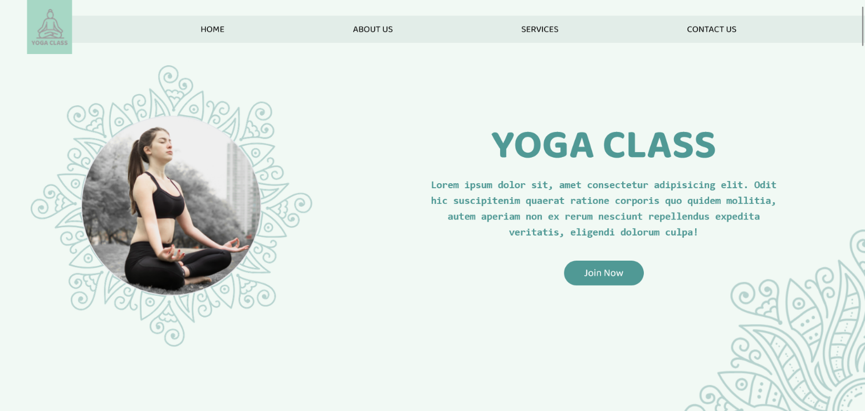



FEE-II, 22CS0014

12

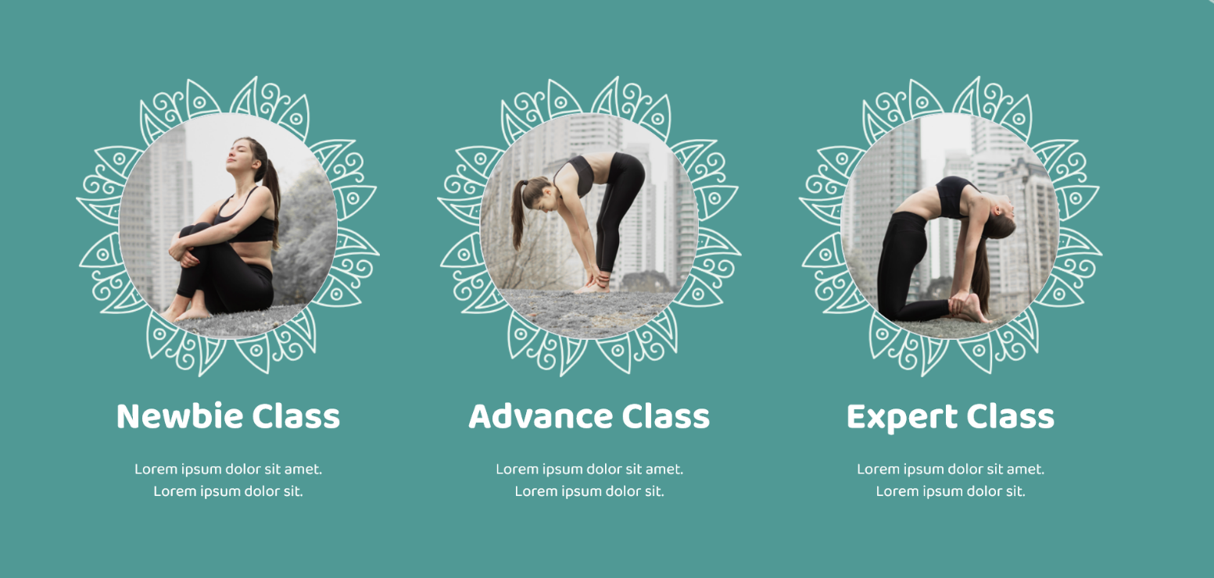

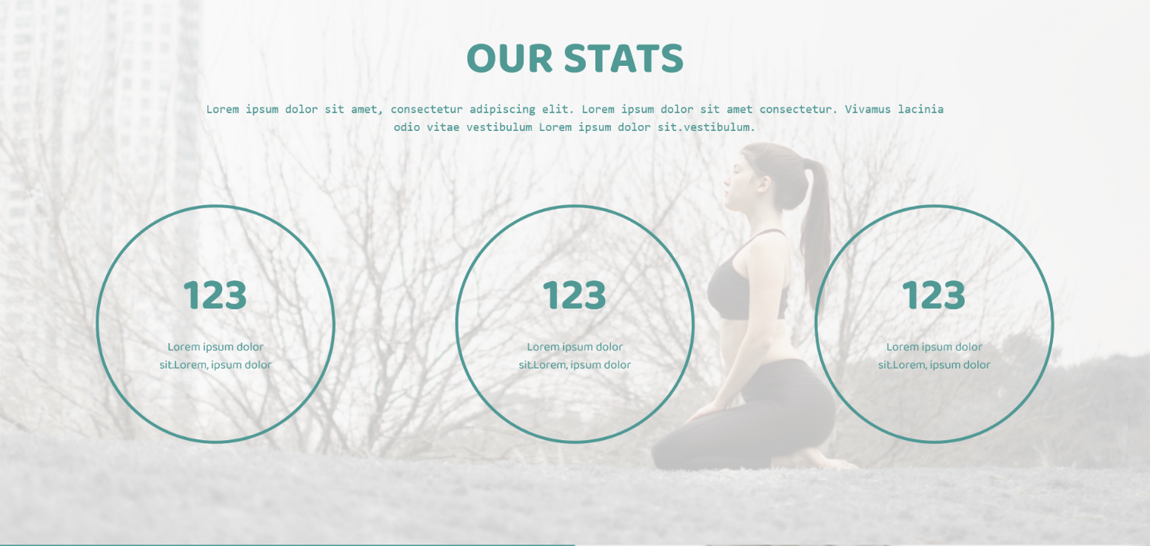

FEE-II,22CS0014

13





FEE-II,22CS0014

14





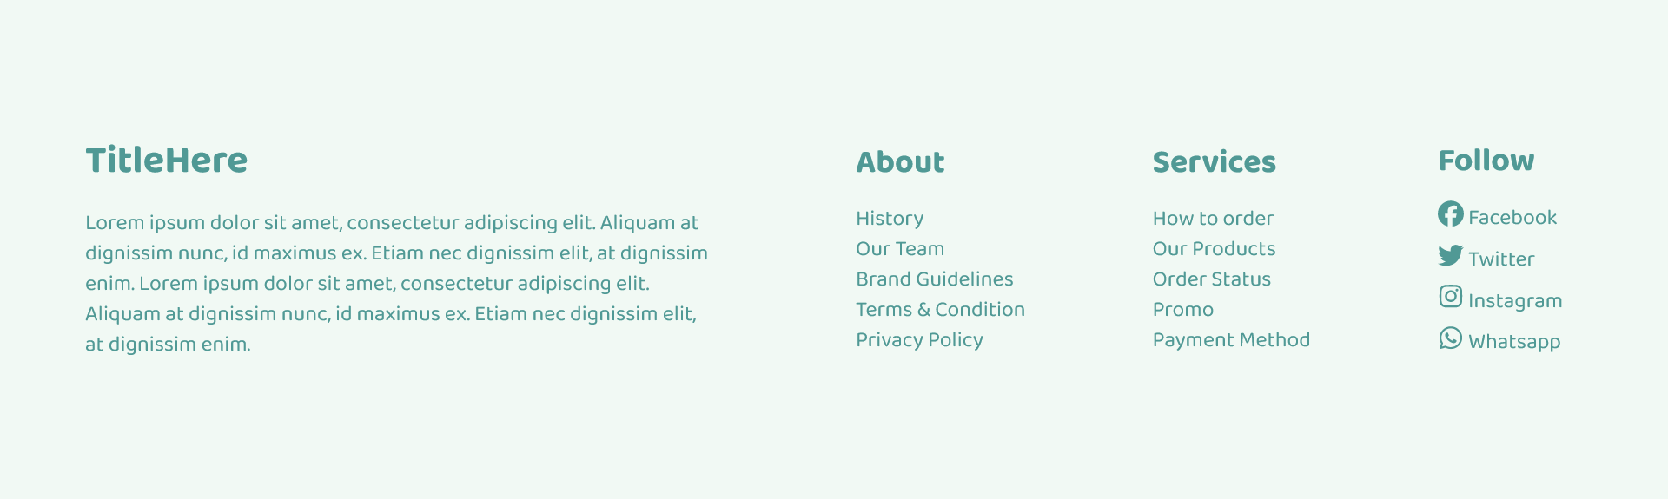

FEE-II,22CS0014

15

**Mobile View Output:**



FEE-II,22CS0014

16



FEE-II,22CS0014

17

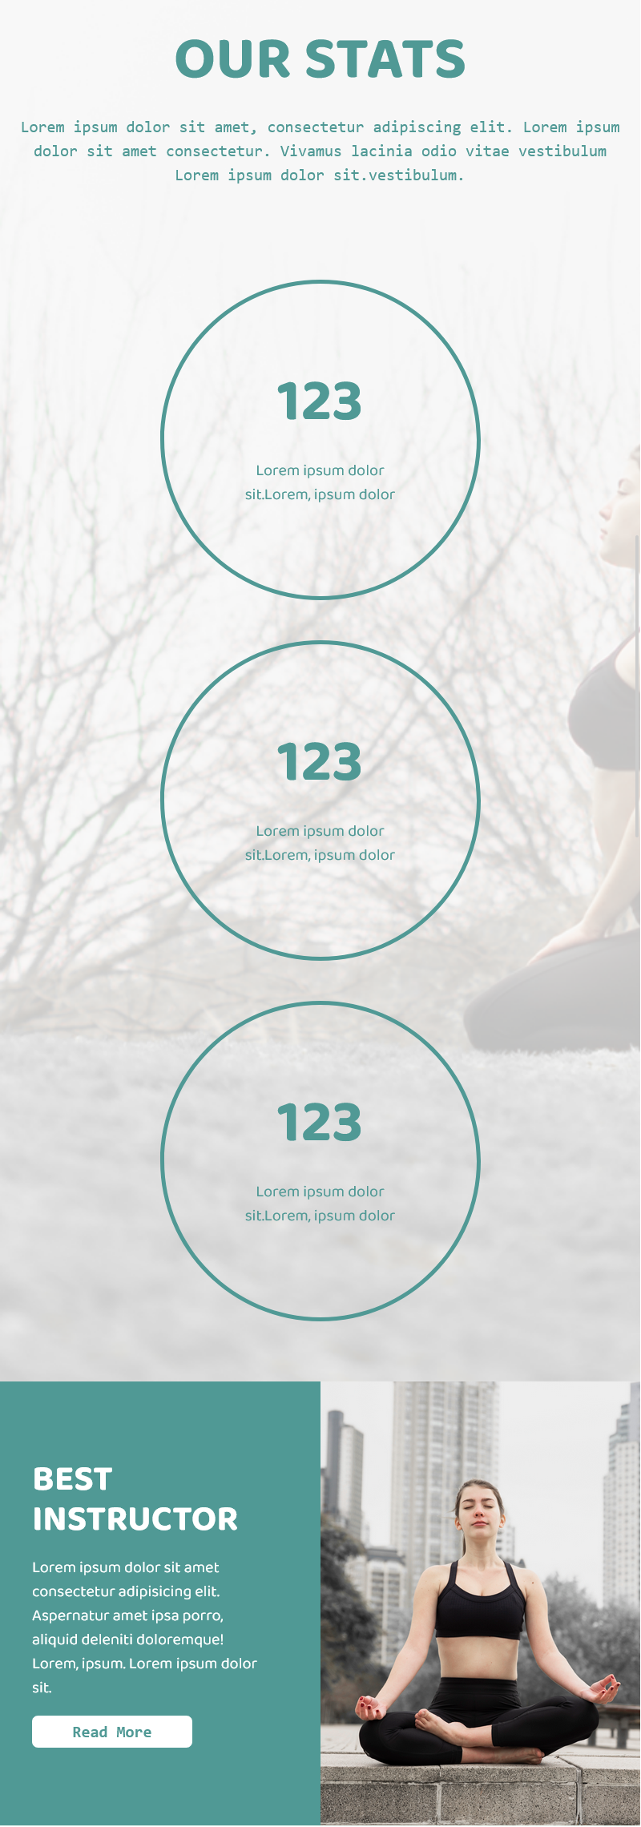

FEE-II,22CS0014

18



FEE-II,22CS0014

19



FEE-II,22CS0014

20



FEE-II,22CS0014

21



FEE-II,22CS001

22

**References:**

1. React Js: <https://react.dev/learn>
2. Tailwind CSS: <https://tailwindcss.com/docs/>
3. Google Fonts: <https://fonts.google.com/>
4. W3 Schools: <https://www.w3schools.com/>
5. Photopea: <https://www.photopea.com/>
6. Font-Awesome: <https://fontawesome.com/>

23

FEE-II, 22CS0014